3.3 Derivatives Worksheets

**Remember that simplifying before attempting to find the derivative is worthwhile**

- Using Leibniz notation , find the derivatives for each of the following functions.

(Note that and are both constants and have a derivative equal to 0)

Use Product Rule

Simplify first!!!

Use Quotient Rule

Simplify first!!!

- Suppose that . Find each of the following:

- What is the equation of line tangent to the graph of at its y-intercept?

The y-intercept of the graph occurs when , so .
So the y-intercept occurs at the point .
We rewrite the given function:
We then calculate the derivative: .
So the slope of the tangent line is given by:

Therefore, the equation of the tangent line is given by:

- If and for all x, find .

- Find the x-value for each point on the graph of where the line tangent to the curve is parallel to the line .

Using the Quadratic Formula we can factor .
Therefore we have:
We want . This happens when:

- Find the equations of the tangent lines to the curve that are parallel to the line .

There derivate of our function is.
We need to find a tangent line that is parallel to the line which has a slope of -3. Therefore, we want an x-value that will make the derivative equal to -3.

These x-values correspond to the points: .

Therefore, the equations of our lines are:

- At what points, if any, does the graph of have a horizontal tangent?

The slope of a horizontal tangent is 0. So we want to know what values of x make .

A horizontal tangent occurs at the points: .

- Find equations of the tangent line and the normal line the curve at the point .

We rewrite the given function as .

We should first check that the problem makes sense. We check to see if the point is on the graph.
. So the point is on the graph.

We then calculate the derivative of the function: .
The slope of the tangent line at is then given by: .

Equation of the tangent line through :

Equation of the normal line through :
The normal line must have the opposite reciprocal slope:

- Compute if .

This means that we must evaluate when .

- Consider the function .
- Find the equation of the tangent line to the curve at the point .

We compute the derivative: . We know .
Therefore the equation of the tagnet line is:

- Find the area of the triangle formed from the coordinate axes and the tangent line to the curve at the point.

We can then sketch the triangle and see that: .
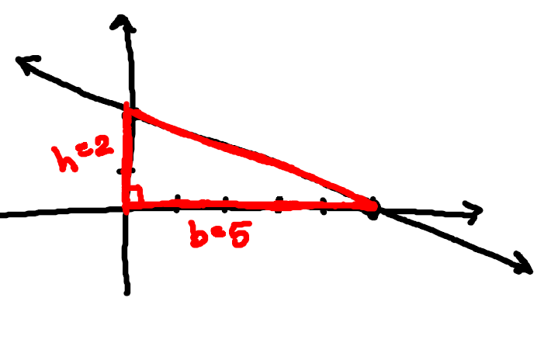

So the area of the triangle is:

TRUE/FALSE
- If f and g are differentiable, then .

TRUE: This is the Sum Rule

- If f and g are differentiable, then
FALSE: We must use the Product Rule

- If , then

FALSE: is a constant and its derivative is 0.

- The derivative of a polynomial is a polynomial.

TRUE: Using the Power Rule or Constant Rule on terms of a polynomial will always result in a polynomial.

